 20MCA136 – NETWORKING & SYSTEM ADMINISTRATION LAB Dept. of Computer Applications

**NETWORKING & SYSTEM ADMINISTRATION LAB**

**Name: Sreelakshmi Madhusoodhanan**

**Roll No: 39**

**Batch: B**

**Date: 09/05/2022**

**Experiment No: 9**

**Aim**

Write a shell script program to display current date and current year.

**Program**

#!/bin/bash

echo "current date: "$(date)

echo "current year calender: "

cal

**Output**

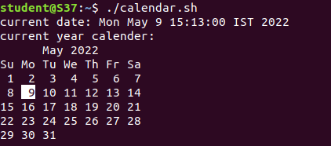

**Experiment No: 10**

**Name: Sreelakshmi Madhusoodhanan**

**Roll No: 39**

**Batch: B**

**Date: 09/05/2022**

**Aim**

Write a shell script program to check a number is greater than, less than or equal to another number.

**Program**

#!/bin/bash

echo "Enter first number : "

read num1

echo "Enter Second number : "

read num2

if [ $num1 -gt $num2 ]

then

echo "First Number is Greatest!!"

elif [ $num1 -lt $num2 ]

then

echo "Second Number is greatest!!"

elif [ $num1 -eq $num2 ]

then

echo "First and Second Number is Equal.."

fi

**Output**

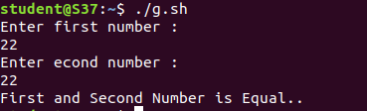

**Name: Sreelakshmi Madhusoodhanan**

**Roll No: 39**

**Batch: B**

**Date: 09/05/2022**

**Experiment No: 11**

**Aim**

Write a shell script to find the sum of first numbers.

**Program**

#!/bin/bash

echo "Enter the first 10 numbers"

read n

sum=0

for((i=0;i<=n;i++))

do

sum=$((sum + i))

done

echo -e "sum is $sum"

**Output**

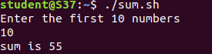

**Name: Sreelakshmi Madhusoodhanan**

**Roll No: 39**

**Batch: B**

**Date: 09/05/2022**

**Experiment No: 12**

**Aim**

Write a shell script program to find sum,average and the product of four numbers.

**Program**

#!/bin/bash

echo "enter four integers"

read a b c d

sum=$(echo "$a + $b + $c + $d" | bc -l)

average=$(echo "$sum / 4" | bc -l)

product=$(echo "$a * $b * $c * $d" | bc -l)

echo "sum = $sum"

echo "Average = $average"

echo "Product = $product"

**Output**

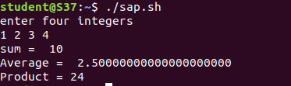

**Experiment No: 13**

**Name: Sreelakshmi Madhusoodhanan**

**Roll No: 39**

**Batch: B**

**Date: 09/05/2022**

**Aim**

Write a shell script program to find the factorial of a given number.

**Program**

#!/bin/bash

echo "Enter a number"

read num

fact=1

for((i=2;i<=num;i++))

{

fact=$((fact * i))

}

echo $fact

**Output**

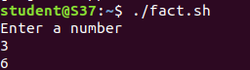

**Name: Sreelakshmi Madhusoodhanan**

**Roll No: 39**

**Batch: B**

**Date: 09/05/2022**

**Experiment No: 14**

**Aim**

Write a shell script program to find a number is palindrome or not.

**Program**

#!/bin/bash

clear

echo "Enter No : "

read no

m=$no

rev=0

while [ $no -gt 0 ]

do

r=`expr $no % 10`

rev=`expr $rev \* 10 + $r`

no=`expr $no / 10`

done

if [ $m = $rev ]

then

echo " $m is Palindrome"

else

echo " $m is not Palindrome"

fi

**Output**

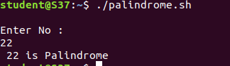

**Experiment No: 15**

**Aim**

Write a shell script the given year is leap year or not.

**Name: Sreelakshmi Madhusoodhanan**

**Roll No: 39**

**Batch: B**

**Date: 09/05/2022**

**Program**

#!/bin/bash

echo "enter the year :"

read y

a=`expr $y % 4`

b=`expr $y % 100`

c=`expr $y % 400`

# -eq is for equal to

#-ne is for not equal to

if [ $a -eq 0 -a $b -ne 0 -o $c -eq 0 ]

then

echo "$y is leap year"

else

echo "$y is not leap year"

fi

**Output**

